# C:\Users\Admin\AppData\Local\Microsoft\Windows\INetCache\IE\A82ZH12Y\music[1].jpg `\

**GAE NEWSLETTER**

**MARCH 2021**

PRESIDENT: [Debbie Meier](mailto:debmeier70@gmail.com)

VP/PROGRAMS: [Gill Cerbin](mailto:gillcerbin@yahoo.com)

SECRETARY: [LeAnn Halvorson](mailto:LeAnnHalvorson@musicperceptions.com)

TREASURER: [Joan Witte](mailto:jcwitte63@gmail.com)

NEWSLETTER: [Debbie Meier](mailto:debmeier70@gmail.com)

WEBMASTER: [Sarah Gallaher McGuirk](mailto:sarah.g.mcguirk@gmail.com)

www.gatewaymusicteachers.org

**UPCOMING EVENTS**

**Friday, Mar. 12 Joint meeting with PTRT of St. Louis – “IMSLP-Its Story and All its**

**10:00 a.m. Uses,” Presented by Carl Simpson**

**March 13-17 2021 MTNA Virtual National Conference**

**MARCH MEETING**

**”IMSLP – It’s Story and All its Uses”**

**March 12, 2021 - 10 AM-Noon**

**Carl Simpson**

*Zoom Link: Will be emailed.*

The International Music Score Library Project/Project Petrucci (IMSLP) is an internet repository of music. For our March presentation, one of its founders, Carl Simpson, will offer a comprehensive look at this amazing resource.

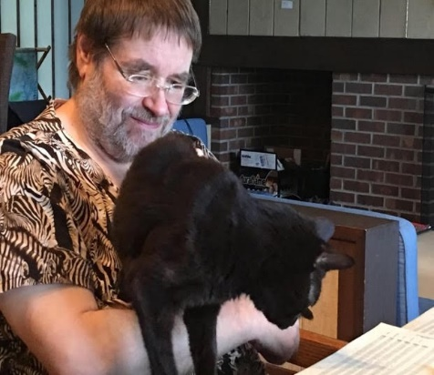            As chief operations officer of IMSLP, Carl has been involved from the beginning with this enormous database of works that has changed the music industry worldwide, making print scores of works that are no longer protected by copyright accessible to all. How did IMSLP come to exist? Why is it threatened with lawsuits so often? And how can we use it as a tool beyond looking up individual pieces? Can you really see Bach’s own handwriting, and what is that clef?

            A St. Louis native, Carl Simpson studied theory and composition under Dr James Woodard at Southern Illinois University where he graduated *cum laude*in 1979. He is also owner of Serenissima Music, LLC, a classical music publishing company, as well as a composer, arranger, and editor.  Leonard Slatkin recorded one of Simpson’s arrangements of the “Promenade” sections of “Pictures at an Exhibition” on the Naxos label. Simpson also had recorded his arrangements of Bartok, Grainger, Tchaikovsky and Debussy.

            As an editor, he has prepared many works, including Tobias Picker’s opera, “Therese Raguin”, which was commissioned by a consortium**including the Dallas O**pera, San Diego Opera, and the Opera de Montreal. An exciting musicologist, he has reconstructed operas and ballets from original manuscripts scattered around the globe. These works had often fallen victim to the egos of divas and prima ballerinas.

            In similar fashion, conductors and musicians have frequently altered major works to suit their situations, creating conflicting scores. Simpson delights in researching the performance history of these works and ferreting out their many variations, using original sources to recreate the composer’s original intentions, as well as the most valid variations His editions of Gilbert and Sullivan’s three biggest successes, “The Mikado”, “Pirates of Penzance”, and “HMS Pinafore” have delighted the audiences of major opera companies, including the Opera Theater of St. Louis, the Dallas Opera, and the Lyric Opera of Chicago. His fluency in Russian has aided his research and restoration of various Russian ballets, including Tchaikovsky’s “Swan Lake”.

            As a composer, Simpson is published by Kalmus, TRN, and Dover. Simpson was previously chief music editor for MMB Music Inc., where he also served as director of the performance and departments, making him ideally suited to the many facets of IMSLP management.

Simpson lives in Edwardsville with his wife, Lois, and their feline, Prinz Maximus von Katzenhoff.

**FEBRUARY REVIEW**

It was a pleasure to be included in the PTRT meeting led by Kyu Butler. Her Zoom presentation was very informative, based on her personal experience of dealing with hand injuries as early as high school and then 7 years ago when she was preparing her final recitals for her doctoral degree. While the size of the piano has grown over time, hand injuries became more common. Among small-handed pianists, there is a limited access of repertoire and it is likely that they will have no career as a pianist along with not being considered as a good pianist. Kyu asked the question “Is the size of the modern piano a good fit for everyone?” No.

Kyu met with [David Steinbuhler](https://amusicallife.com/david-steinbuhler-developer-of-smaller-piano-keyboards/)*and ended up purchasing a piano with a smaller sized keyboard. He has several alternatively-sized piano keyboards that are free to universities, music communities, and music organizations in the U.S. It was interesting to know that the action of one of these keyboards could be swapped with a regular-sized piano. Needless to say, that requires a technician each time this needs to be done.

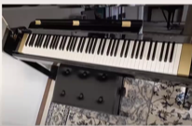 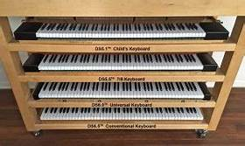 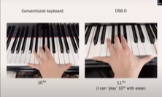

Kyu’s purchase of the piano with a smaller keyboard is used as her practicing instrument. She said it is an entry-level piano so the sound is not great but it provides her the opportunity to practice without reinjuring her hands and she finds it relatively easy to adjust switching between the alternatively-sized piano and a conventional piano.

It was also noted that Steinway built a special piano for pianist Josef Hofmann (1878-1957), a Polish-born child prodigy and virtuoso pianist, who had a hand so small that he could reach no more than an octave. With this special piano, in which the ivories were slightly narrower, he could reach a ninth. He traveled extensively with these pianos with their custom Keyboard and action…” (stated by Ronald Ratcliffe in his book “Steinway”)

While this does not seem like a practical solution because of the high cost involved, Kyu concluded that this research can raise awareness of the benefits of using alternatively-sized piano keyboards and that they have been commercially available since the 1990’s. She feels we should encourage piano manufaturers to make these alternatively-sized pianos so that there is a way to reduce risk for injuries and so that small-handed pianists can select repertoire with no limitation. She also noted that the Dallas International Piano Competition has been offering these alternatively-sized pianos to the contestants and feels that other performance venues should provide them for performances, making it acceptable to use them.

* The Pennsylvania-based firm was founded in 1991 by David Steinbuhler, a textile manufacturer, who worked with pianist Christopher Donison to create the “Donison-Steinbuhler Standard,” or DS keyboard. The DS keyboard at UW-Madison cost $11,000, and can be swapped in and out of the grand piano by a trained piano technician.

**TIDBITS**

From Yeeseon Kwon, our ISMTA President:

Anticipating ISMTA State Conference 2021:

Dr. Chee Hyeon Choi, VP – Conferences and I have been discussing the pandemic landscape for our conference options for 2021 and the safe viability of these options. Considering the slower than anticipated vaccine rollout across the nation and certainly in IL as well, we are anticipating a Virtual Conference for Nov. 5-6, 2021, with further discussions at the Spring ISMTA Board Meeting. Conference planning work is already underway as it is necessary to begin the planning work, such as reaching out to the network of artists and clinicians and setting various plans. Considering the success of our 2020 Virtual Conference, I am confident that we can expand and offer some exciting ways to involve our membership in both virtual and live events.

Competitions: **NEW!**

I would like to put on everyone’s radar the **2021 ISMTA Instrument and Voice Competition.**Jennifer Cohen, Competitions Director has been working with our new ISMTA Instrument and Voice Competition Coordinator, Justin Kothenbeutel, who will be running this exciting new competition. [https://ismta.org/ismta video competition](https://ismta.org/ismtavideocompetition)

Please do your part and share this information with high school bands and choral colleagues. I am so impressed with how quickly and how well organized this new competition has opened up for this timely rollout. Thank you also to Chris Goldston for executing the logistics on the ISMTA website in timely ways. Great coordination of leadership and teamwork!

**AIM Report**

AIM Theory testing has been completed and it appears to have gone smoothly. According to information received, 42 students were tested: Level 3=eleven students, Level 4=nine students, Level 5=four students, Level 6=six students, Level 7=six students, Level 8=one student, Level 9=two students, and Level 10=3 students.

All GAE members should have received revised AIM registration forms for all students and teachers who will be participating in non-SIUE performance exams. Please use these forms instead of the ones that were in the AIM Supplement sent out earlier in the year. All students and teachers will have a choice of taking/judging exams in person or remotely. Contact [Joan Witte](mailto:jcwitte63@gmail.com) if you have questions.

**MEMBERSHIP NEWS AND NOTES**

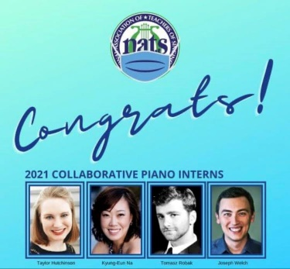 The National Association of Teachers of Singing (NATS) has selected **Dr. Joseph Welch** as one of sixteen 2021 Intern Program participants along with other early career voice teachers and collaborative pianists for an intensive training experience at Georgia Southern University in Statesboro, Georgia for 10 days in June. Congratulations, Joe. We are proud of you!

From former member, **Tara Wright**, who is Education Director at Swing City Music in Collinsville:

I wanted to reach out to you and the rest of the GAE members.  I have recently taken on a position with [Tim Topham](topmusic.co)--I am the Topmusic Marketplace Manager.

I am looking for other music teachers who create teaching resources and would like to sell them. Tim has a large platform and I am currently reworking the website to make it easier to navigate for teachers. This is a great opportunity for teachers to get their teaching resources in front of thousands of other teachers and make a little extra cash.

Here is the website for anyone to check out: <https://topmusicmarketplace.com/>.

I'm happy to help anyone who has questions!  They can email me at [Tara@topmusic.co](mailto:Tara@topmusic.co)

I am also looking to hire another piano and guitar teacher at Swing City Music.  If anyone has prior/current students who are wanting to teach, send them my way!

Tara Wright

Education Director

Swing City Music

[Education Website!](https://www.swingcitymusic.com/music-lessons/)

1811 Vandalia St.

Collinsville, Il. 62234

618-345-6700

What are you doing right now to make sure you’re ready for events you’ve been invited to be a piano judge? Please review February’s Newsletter for tips on judging piano contests/exams.

Last, but not least, this video is worthy of watching: It is from the Virtual 2020 MTNA Conference and is titled “What the Judges Hear,” a panel presentation by Peter Mack as he interviews 3 other teachers: <https://ismta.org/VConf_NatlReplays>

