`\
GAE NEWSLETTER
AUGUST 2021
PRESIDENT: Debbie Meier
VP/PROGRAMS: Gill Cerbin
SECRETARY: LeAnn Halvorson
TREASURER: Joan Witte
NEWSLETTER: Debbie Meier
WEBMASTER: Sarah Gallaher McGuirk

www.gatewaymusicteachers.org

UPCOMING EVENTS

Friday, Sept. 10 20/20 Vision for Piano Teachers – Building a Foundation for Expressive
10:00 a.m. Performance, Presented by Janna Williamson
Venue: 231 W Waters Edge Dr., Belleville, IL 62221 (Gill Cerbin’s home)

Friday, Oct. 15 Joint PTRT/GAEMTA program in St. Louis & Zoom
10:00 a.m. “The Dog Ate My Homework” – Michele Sisler

November 5 & 6 ISMTA Virtual Conference

Friday, Nov. 19 Round Table Discussion/ISMTA Conference Feedback

SEPTEMBER MEETING

September 10th at 10:00 a.m. is the kick-off for our first meeting of the year and it’s one you won’t want to miss! We are excited to have Janna Williamson join us all the way from Chicago. She is the daughter of St. Louisan Annette Burkhardt, who has presented for us in the past. The apple doesn’t fall far from the tree! “Music has been a part of Janna Williamson’s life since she was in utero. Whether playing solo or collaborating with individuals or groups, Janna values personal expression at the instrument and gravitates towards music full of lyricism and meaning. Her favorite composers include (but are not limited to!) Bach, Mozart, Schubert, Prokofiev, and Poulenc. A great appreciator of new music, Janna savors opportunities to work creatively and use extended techniques.” Be sure to check out Janna’s website.
This Photo by Unknown Author is licensed under CC BY-SA

Janna’s presentation titled 20/20 Vision for Piano Teachers – Building a Foundation for Expressive Performance should be one that is of interest to everyone, finding a way of helping our students to play expressively. Invite a friend!
This Photo by Unknown Author is licensed under CC BY-SA

Thank you, Gill, for opening your lovely home to host this meeting! We certainly appreciate your hospitality! The address is 231 W. Water’s Edge Dr., Belleville, IL 62221
Janna Williamson
20/20 Vision for Piano Teachers:
Building a Foundation for Expressive Performance

Friday, September 10th, 2021 at 10:00am
231 W Waters Edge Dr., Belleville, IL 62221

Imagine a student exiting your studio after a decade or more of study with you, moving from the earliest beginner stage to a capable, accomplished student. Do you have intentional strategies for how to achieve that vision? In this session, Janna Williamson will discuss the importance of a clear vision and examine how having a vision specifically for expressive advanced performance can inform our teaching at the elementary and intermediate levels. Musical expression can and should be strategically taught at the lowest levels, and our own experience as more advanced musicians and performers should be incorporated in how we train even the least advanced students.
By way of comparison, Janna will perform a Bach Prelude from the Well-Tempered Clavier and a movement of a Mozart Sonata in order to compare them with lower level pieces, such as the Bach Minuet in D Minor, BWV 132, and the easy Spindler Sonatina in C Major (first movement). This session is intended to be exceedingly practical for all levels of teaching and will have direct applications for teachers using the AIM curriculum.
Bio: Janna Williamson, NCTM, is a pianist, educator, and collaborator. Janna enjoys high retention in her independent piano studio in the suburbs of Chicago as well as the rewards of students who have gone on to enjoy a lifetime of music. A teacher of teachers, Janna is a Content Creator for TopMusicPro and coaches less experienced piano teachers through her online teacher consultation service. Janna holds piano performance degrees from the Chicago College of Performing Arts (Roosevelt University) and Wheaton College Conservatory of Music (both summa cum laude) and is active in the Illinois State Music Teachers Association as well as the West Suburban Music Teachers Association. She was voted Teacher of the Year for the WSMTA in 2021. More information can be found at jannawilliamson.com

MEMBER NEWS AND NOTES
Greg Junker states that he has customers that are retired music teachers from Central Illinois. They have boxes of music, if anyone is interested. Their contact information is Mr. & Mrs. Jim McNary @ 618-726-7541.
From Catherine Burge: Belleville Philharmonic has been going strong with Chamber music and outdoor concerts -There will be a full orchestra and Bellville Ballet NUTCRACKER performance at the former Scottish Rite Cathedral (now a church) the weekend before Thanksgiving! Come out and support your local talent--see website for updates.
Catherine states “We've relocated to an HOA restricted community in Mascoutah and can accept new students at my studio location, St. John United Church of Christ, Mascoutah, with occasional meetings/recitals at my home studio where the grand piano lives in its own room. Hopefully we can host a meeting sometime!
I’m still working a full class and private piano students at Forest Park campus of STLCC--I love this work!

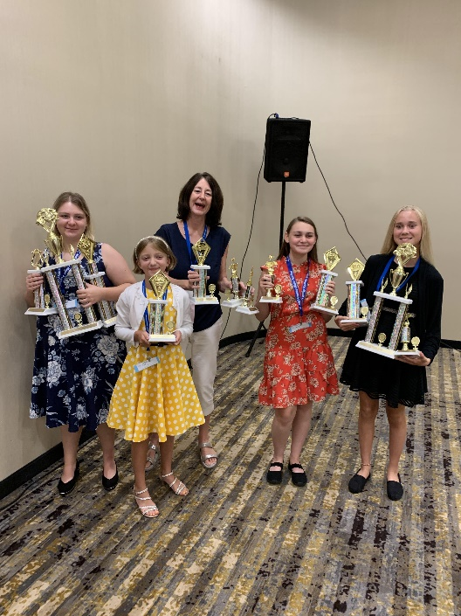
Students of Gill Cerbin attended the Kansas City M.A.M.A. competition and brought home trophies in solo piano, piano concerto, piano duet, art song, and music theater categories. Participants also enjoyed performing for each other at a studio recital the previous week.

Gill and daughter Lauren hosted a morning coffee concert of songs from the musicals which was a lot of fun. Proud mom Gill also shared that Lauren won a scholarship with Opera St. Louis to continue her private voice lessons with Dr. Schapman of SIUE. Congrats, Lauren!

Gill also states: “As AIM Chair I was moved to receive a thank you note from level 9 student Aidan Sawyer (grandson of Amy Jo) for his AIM check.”

Pictured above: Teacher Gill Cerbin with her M.A.M.A. students holding their trophies

Two piano students of Dr. Stephanie Owen have been invited to send in a clip for West Coast Junior Rag Festival in California. Their names are Elan Feldhake and Landan Pierce. They will submit Maple Leaf Rag and Easy Winners.
Evan Totsch, vocal student of Dr. Stephanie Owen, was selected as children's lead in Beauty and the Beast at the Hett in Lebanon. Director Halli Pattison studied with Dr. Jolly at St. Louis University, the Globe Shakespeare Theatre in London, England, and the City of London Lyric Theatre.

Dr. Stephanie Owen has been invited to be a vocal coach for O’Fallon Township High School with specialties in French, Latin, Italian, German, and Spanish diction.

TEACHING OPPORTUNITY: from Catherine Burge: I want to announce that there are openings for piano/keyboard teachers every day of the week at the Fairview Heights location of Music and Arts. Interested people can contact me first to recommend them for this program--it may help with their income level from teaching at this studio! All teaching studios have at least one keyboard with 88 keys. Many other instruments are featured as well -- great chance to experiment and find out what works for students! Contact Catherine at: caburge@gmail.com or phone (618) 704-5730.

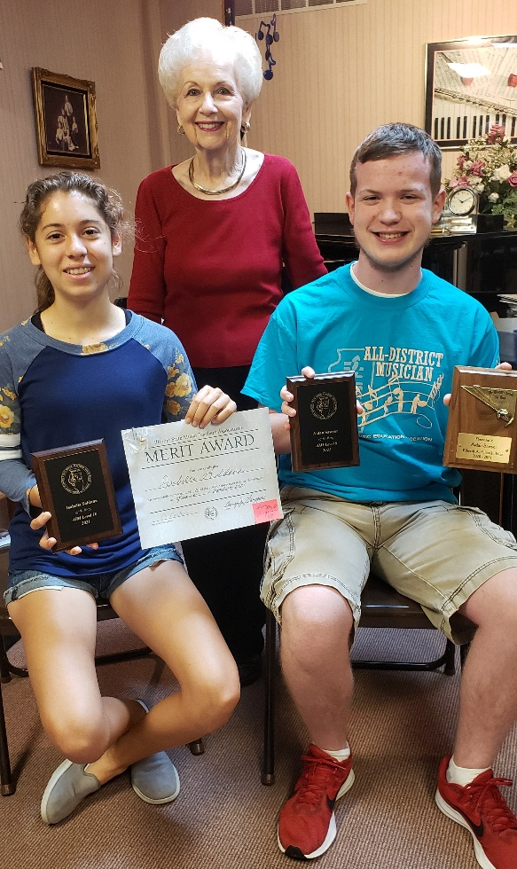
Two of Amy Jo Sawyer’s piano students, Isabella Saldana and Aidan Sawyer, recently received many awards for their musical talents. Grandson Aidan received the “Director’s Award” for being the top music student at Fulton Jr. High in O’Fallon. He composed an original jazz piece entitled “Funko.” The Junior High Jazz band performed his piece on their last concert of the season. He played both piano and trumpet in the Jazz Band and he also played trumpet in Symphonic Winds orchestra at Fulton. Aidan will be a freshman at OTHS in the fall.

Isabella Saldana plays flute in the OTHS Wind Ensemble and St. Louis Symphony Youth Orchestra. She has won many awards in flute including 1st place in the UMSL Young Artist Competition and 2nd place in the Flute Society of St. Louis High School Young Artist Competition. Her flute instructor, Dr. Shelly Monier, is on the faculty of SIUE. Isabella will be a junior at OTHS in the fall.

Pictured to the right with Teacher Amy Jo Sawyer are Isabella Saldana (receiving her levels 9 and 10 A.I.M awards) and Aidan Sawyer (receiving his plaques for level 9 A.I.M. and “Director’s Award”)

MTNA Foundation Fellows
The Music Teachers National Association (MTNA) Fellow program offers a meaningful method for honoring deserving individuals while supporting the efforts of the MTNA Foundation Fund through a donation to the Foundation Fund in an individual's name. Anyone can nominate and fund an MTNA Fellow. Each year, the ISMTA board nominates one fellow, and raises funds to fund that fellow.
This year’s nomination, Cathy Albergo, is a former ISMTA member, a Past President of ISMTA and she also served as National Certification Chair of MTNA. She is currently Professor of Music at Florida Gulf Coast University and is a nationally recognized authority on piano instruction and a frequent lecturer, adjudicator, and workshop clinician. She is co-author of Piano Repertoire: A Guide for Teachers, published by Stipes Publishing Co., and the Celebration Series Handbook for Teachers, as well as the elementary piano method, Celebrate Piano!

Once a fellow is nominated, the State must contribute $1,500 to the MTNA Foundation Fellow Fund. I would encourage you to do your part and contribute to the MTNA Foundation Fund by helping fund the ISMTA fellow. Go to the ISMTA.org website, click on Teachers and then choose MTNA Foundation Fellows from the drop-down menu. Click on the donate button.

TIDBITS
This Photo by Unknown Author is licensed under CC BY-NC
FASTER, HIGHER, STRONGER - TOGETHER! The Olympic motto was amended to stress the importance of solidarity within the Olympic Movement and beyond. Solidarity is at the heart of everything we do. It fuels our mission to make the world a better place through sport. We try to accomplish something similar with MUSIC. The one language that everybody understands no matter what tongue they speak is music. Studies show that there are six emotions: happiness, anger, fear, sadness, disgust, and surprise. How do you and your students use music to make the world a better place?

TOP TEN TIPS FOR PIANO TEACHERS
Be sure to check out Janna Williamson’s BLOG on her website: jannawilliamson.com
Her first tip is –

Encourage students to perform regularly, and provide them with developmentally appropriate performance opportunities.

Janna brainstormed and came up with a list of examples going from least formal to most. She also shares several teaching videos which you may find very useful.

