# C:\Users\Admin\AppData\Local\Microsoft\Windows\INetCache\IE\A82ZH12Y\music[1].jpg `\

**GAE NEWSLETTER**

**JUNE UPDATE 2021**

PRESIDENT: [Debbie Meier](mailto:debmeier70@gmail.com)

VP/PROGRAMS: [Gill Cerbin](mailto:gillcerbin@yahoo.com)

SECRETARY: [LeAnn Halvorson](mailto:LeAnnHalvorson@musicperceptions.com)

TREASURER: [Joan Witte](mailto:jcwitte63@gmail.com)

NEWSLETTER: [Debbie Meier](mailto:debmeier70@gmail.com)

WEBMASTER: [Sarah Gallaher McGuirk](mailto:sarah.g.mcguirk@gmail.com)

www.gatewaymusicteachers.org

**Reminder:** If you have any changes in your contact information, please send the information to President [Debbie Meier](mailto:debmeier70@gmail.com) for the Membership/Yearbook.

**Membership Renewal**

The MTNA, ISMTA and GAE’s fiscal year is July 1-June 30. If you haven’t renewed your membership, please do so; don’t delay! Taking care of this now will assure that your name will be included in our Membership directory. Thank you!

## **SAVE THE DATES:  NOVEMBER 5-6, 2021**

Out of an abundance of caution due to COVID, ISMTA has decided that the 2021 conference will again be virtual.  The 2021 State Conference will be held online November 5-6, 2021. Stay tuned for more details!   Featuring Conference Clinician Dr. E. L. Lancaster and Conference Artist Dr. Ian Hobson.



This Newsletter is several pages long – PLEASE read to the end!

**UPCOMING EVENTS**

The Executive Board met on June 11 and discussed events and programs for the upcoming year. We set dates and are finalizing the first half of the year through January 2022. We have some great programs in place and you will see a draft of our programs in this Newsletter. The kick-off for our first program is set for **September 10**. Put this on your calendar now—you won’t want to miss it! Our program will be presented by **Janna Williamson** of Chicago (who just happens to be the daughter of St. Louisian Annette Burkhardt, who has presented for GAE in the past!).

**Janna Williamson**

20/20 Vision for Piano Teachers:

Building a Foundation for Expressive Performance

**Friday, September 10th, 2021 at 10:00am**

231 W Waters Edge Dr., Belleville, IL 62221



Imagine a student exiting your studio after a decade or more of study with you, moving from the earliest beginner stage to a capable, accomplished student. Do you have intentional strategies for how to achieve that vision? In this session, Janna Williamson will discuss the importance of a clear vision and examine how having a vision specifically for expressive advanced performance can inform our teaching at the elementary and intermediate levels. Musical expression can and should be strategically taught at the lowest levels, and our own experience as more advanced musicians and performers should be incorporated in how we train even the least advanced students. By way of comparison, Janna will perform a Bach Prelude from the Well-Tempered Clavier and a movement of a Mozart Sonata in order to compare them with lower level pieces, such as the Bach Minuet in D Minor, BWV 132, and the easy Spindler Sonatina in C Major (first movement). This session is intended to be exceedingly practical for all levels of teaching and will have direct applications for teachers using the AIM curriculum.

Bio: Janna Williamson, NCTM, is a pianist, educator, and collaborator. Janna enjoys high retention in her independent piano studio in the suburbs of Chicago as well as the rewards of students who have gone on to enjoy a lifetime of music. A teacher of teachers, Janna is a Content Creator for TopMusicPro and coaches less experienced piano teachers through her online teacher consultation service. Janna holds piano performance degrees from the Chicago College of Performing Arts (Roosevelt University) and Wheaton College Conservatory of Music (both summa cum laude) and is active in the Illinois State Music Teachers Association as well as the West Suburban Music Teachers Association. She was voted Teacher of the Year for the WSMTA in 2021. More information can be found at [jannawilliamson.com](http://jannawilliamson.com)

**2021-2022 GAE UPDATES**

For our upcoming year, our Executive Board members remain the same as last year. Deborah Meier, LeAnn Halvorson, and Joan Witte are completing the 2nd year of their two-year terms. Thanks to Gill Cerbin who stepped in last year to fill the VP/Program Coordinator position last fall. Thank you, also, to the Chairpersons who are

willingly donating their time in their positions listed below. We are always looking for new members to our local association so if you know of anyone that is not a member, please extend them an invitation. If anyone currently is not holding a position but would like to get involved, please let one of the Board members know that you are interested.

**2021-2022 GAE Executive Board:**

Deborah Meier, President

Gill Cerbin, Vice President/Program Coordinator

LeAnn Halvorson, Secretary

Joan Witte, Treasurer

**Chairpersons:**

A.I.M.: Gill Cerbin

Membership: Deborah Meier

Certification: Gill Cerbin

Newsletter: Deborah Meier

Directory: Deborah Meier

AIM Theory Scheduler and Aural Exam CD Recorder: LeAnn Halvorson

AIM Performance Scheduler: Joan Witte

AIM Repertoire Checkers: Deborah Meier, Ruth Stith,

Mary Anderson, Huei Li Chin

AIM Exam Printing, Collating, and Binder Preparation: Gill Cerbin

AIM Site Coordinator for SWIC: Gill Cerbin

AIM Site Coordinator for SIUE: Huei Li Chin

Schubertiad Coordinator: Deborah Meier

Webmaster: Sarah Gallaher McGuirk

**MEMBER NEWS AND NOTES**

Shared by **Dr.** **Stephanie Owen**: Three vocal students of Dr Stephanie Owen won prizes: Evan Totsch-Vienna Austria Enkor competition, 3rd prize; Emma Petraborg-second and third prize Great Composers series London England May 2021; Jadzia Zaborski-3rd prize Great Composers series London England May 2021. Congratulations!

We are pleased to announce that starting July 1st, **Gill Cerbin** is taking over as the **State Certification Chair**, replacing Susan Lipnick, a former GAE member! Thank you, Gill, for your service to ISMTA!

And, there’s more exciting news about **Gill**…*drum roll, please!* She has taken the necessary steps to becoming a U.S. Citizen. She will maintain dual citizenship with her beloved England, but we are excited for her as she later attends the Oath ceremony. Congratulations, Gill!

**Joe Welch** enjoyed his internship with the NATS and then took a well-deserved short vacation. Here is a quick summary of his internship:

When I left for my internship in Georgia with the National Association of Teachers of Singing, I was expecting to grow as a musician and teacher.   However, I did not anticipate working in such varied styles.  Almost all of my playing was pop, rock, and jazz.  I spent the two weeks playing from lead sheets and chord charts and creating arrangements of rock songs, doing my best to replicate a band from the piano.  I also worked with a singer-songwriter to help create and perform his music.  I'll share the performance when the recordings are available.  My master teachers were Michelle Markwart Deveaux, who has an independent studio in California, and Craig Terry, Music Director of the Ryan Opera Center at Lyric Opera of Chicago.  We also had a great time with fifty people singing together without masks - because we were 100% vaccinated!  It was so good to make music together in a pre-pandemic way.

And now some other **NOTES**:

**For anyone who is taking new students…**

My name is **Amy Seibert**, and I am a piano teacher with a few students in the Mascoutah/Freeburg area. Unfortunately, my career is shifting away from teaching, and I would love to find a home for my 4 students. Are there any teachers in GAEMTA that are in need of students for the coming school year? If so, I'm happy to give them background on these 4 students (all 4 of them girls between the ages of 9-11), and if it makes sense, to give them the contact info of these students' families.

Thank you for considering! This is the best way to reach me, at [AmyJSeibert@gmail.com](mailto:AmyJSeibert@gmail.com).

**Mary Anderson** recently received a phone call from Michael Aldeguer. He is associated with Scott Air Force Base and is looking for interested musicians in the area that would be able to play for church/chapel services at Scott AFB. If you are looking to earn some extra money or know of another musician that may be interested, please contact Michael at this phone number: (407) 602-7780.

**Marshall Gurley** has informed me that he has a Story and Clark console piano (it was his teaching instrument) that needs a new home. He is willing to give it away to anyone that is in need of a piano. Along with that, he has boxes of music that he also needs to give away to anyone interested as he is not able to teach any longer and he doesn’t want to just throw it away. If anyone in our group knows of a way this music can benefit someone, please contact him at (618) 271-0201. He would be most appreciative.

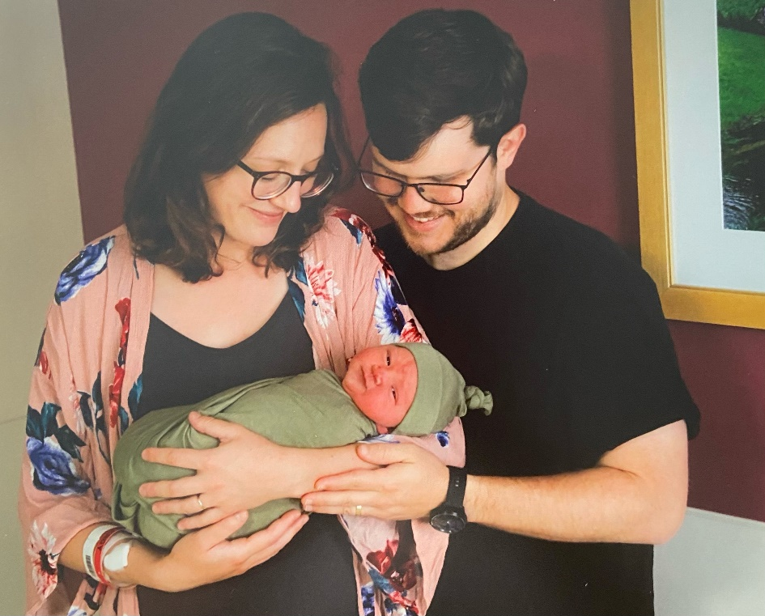And, exciting **Baby news!**

Matt and **Sarah McGuirk** welcomed their daughter Rose Carol McGuirk on May 25th. Sarah reports that all are happy and healthy! Congratulations to the happy family!

Sweet as a rose…



 **Piano legend Ruth Slenczynska** (who has former ties to SIU-E) is still alive and well! Born January 15, 1925, she is now 96. *(As I was perusing some older GAE Newsletters, I read about the presentation given to GAE by Dr. Ho, Millie’s husband, several years ago in Lovejoy Library. I remembered how fascinated this program was and it got me googling and wondering about Ruth.)*

Click the link below to listen to a fabulous interview from February 2020. This podcast is a real delight. Ruth is so charming! She shares stories about playing for Rachmaninov and Horowitz and you will also hear some of her wonderful recordings.

Track titles include:   
Moment Musical in F minor, Op.94 No.3 by Schubert, Waltz No.1 Op. 64 (Minute Waltz) and Ballade No. 1 in G minor, Op.23, both by Chopin, Transcendental Etude No. 5 (Feux follets) by Liszt, and Prelude in Eflat, Opus 23 by Rachmaninov.

For her latest release, check out her Complete American Decca Recordings (see below).

**https://www.eloquenceclassics.com/releases/ruth-slenczynska-the-complete-american-decca-recordings/**

**CD Title:** Ruth Slenczynska: [Complete American Decca Recording](mailto:https://www.amazon.com/Complete-American-Recordings-SYMPHONIKER-SLENCZYNSKA/dp/B08MQS5HGQ/ref=sr_1_1?dchild=1&keywords=Ruth+Slenczynska+%E2%80%93+Complete+American+Decca+Recordings+Ruth+Slenczynska&qid=1622432229&s=amazon-devices&sr=1-1)s was released in November 2020. This collection contains 10 CDs. **Record Co/Number:** Eloquence 484 1302

**To listen to the** **podcast**: (**Duration:**54min 6sec **Broadcast:**Sat 5 Dec 2020, 11:05am) click on the link below:

https://www.abc.net.au/radionational/programs/musicshow/ruth-slenczynska-chopin-rachmaninov-horowitz-liszt-bach/12943440

“A conversation with 95-year-old Ruth Slenczynska, on the release of her [Complete American Decca Recordings](https://www.eloquenceclassics.com/releases/ruth-slenczynska-the-complete-american-decca-recordings/). She was a childhood prodigy (although she denies the label) which came at a huge price, including a punishing concert schedule from the age of 4, orchestrated in the main by a tyrannical teacher-father. Ruth went on to be one of the great pianists of the 20th century. She played duets with Harry Truman, toured with Arthur Fiedler and the Boston Pops, and was taught by Artur Schnabel, Egon Petri and Sergei Rachmaninov - to whom she is possibly the last remaining student link. Ruth is still playing, and only COVID-19 stopped her planned tour of Japan this year (2020). Tune into a long and engaging conversation with Ruth Slenczynska from her home in New York.”

**GAE History Tidbits**

Did you know that Gateway Arch East Chapter of the ISMTA was formerly known as the Springfield South Area Group and was chartered in April 1981. Back in 1983-1984, our chapter had 21 members and 180 Syllabus entries. Professor Karen Rogers (head of Keyboard Development at SIU-E) played a big role in organizing Syllabus exams and she completed levels 1-5 in her first edition of the Syllabus Manual in 1986. The ISMTA Convention was held at SIU-E in 1988 and again in 1995. In 1991-1992, we had 2 sites for holding A.I.M. exams and at that time, Debbie Meier and Marian Chao were A.I.M. Co-Chairs at SIUE while LeAnn and Amy Jo co-chaired at SWIC (then B.A.C.). The following year, LeAnn and Debbie took over as A.I.M. Co-Chairs with LeAnn taking care of Theory duties and Debbie, Performance.

Imagine scheduling as many as 262 students in two different locations at one time. That was our highest number of entries during 1996-1997. The following year was the first time we actually scheduled the theory exams separate from the performance dates! It was an adjustment for everyone though well-received. In 1998-1999, our chapter had a record number of 40 members and in 2001-2002 the A.I.M. exams took on its new name (Achievement in Music) from the former title of Syllabus. And one final tidbit, 1997-1998 was the first year that ISMTA honored teachers with the chapter Member-of-the-Year awards.

**GAE 2021-2022 MEMBER-OF-THE-YEAR**

It was my pleasure to meet with **Marshall Gurley** in May at his new residence in Collinsville. He is very honored to be chosen as Gateway Arch East’s Member-of-the-Year as he joins the list of well-deserved honorees.



**Marshall Gurley, 2021-2022 GAE Member-of-the-Year**

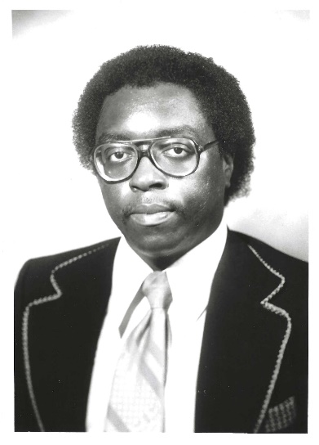 Marshall Gurley grew up with his family in St. Louis and then later relocated to East St. Louis. His grandfather played the fiddle and his brother played oboe and clarinet. Marshall sang in his church choir and started formal piano lessons at the age of eight. He also dabbled in clarinet for a few years. His high school choral director, David Brown was a big influence in Marshall’s life which led to a love of music that inspired him to teach. He graduated from S.I.U.-Carbondale with a Bachelor of Music in Fine Arts and later attended S.I.U.-Edwardsville where he obtained his Master of Music degree. Marshall taught music for over 20 years in the public school system in the St. Louis area. He has operated an independent music studio in East St. Louis for 50 years, teaching piano, voice, and music theory. Several of his students have performed at the Muny Opera ([St. Louis Municipal Opera Theatre](mailto:https://muny.org)) and have become music teachers and church musicians in different parts of the country. Marshall also served for 60 years as pianist and/or choir director at his church, Truelight Baptist Church in East St. Louis.

Marshall was a founding member of the East St. Louis-based Westbrook Green Concert Choir, and he served either as pianist, director, or baritone soloist. Another highlight in his career was teaching vocal classes at the famed James Cleveland Gospel Music Workshop of America. He always looked forward to attending the yearly workshops that were held in various parts of the country with up to 20,000 delegates assembled together in the selected city for a teaching, learning, and performance orientated environment. [James Cleveland Chorus - Gospel Music Workshop of America (jcchorus.com)](http://www.jcchorus.com/RevCleveland.htm)

Marshall has been an active member of Gateway Arch East Chapter for 42 years, joining in October of 1979, and he served as secretary of the group for several years. Along with the social aspects of meeting with other music teachers in this group, he enjoyed other benefits such as learning new ideas from other teachers, gaining professional development, and involving his students in recitals and the A.I.M. piano exams. When asked what advice he might give to a young music teacher, Marshall said to keep growing and learning and find an organization to belong to such as GAE.

*From* ***Debbie:***

I had another visit with Marshall on June 18, and while there I found out that it was his birthday. Happy Birthday, Marshall! While there, Marshall gave me a card addressed to all the members of GAE.

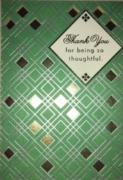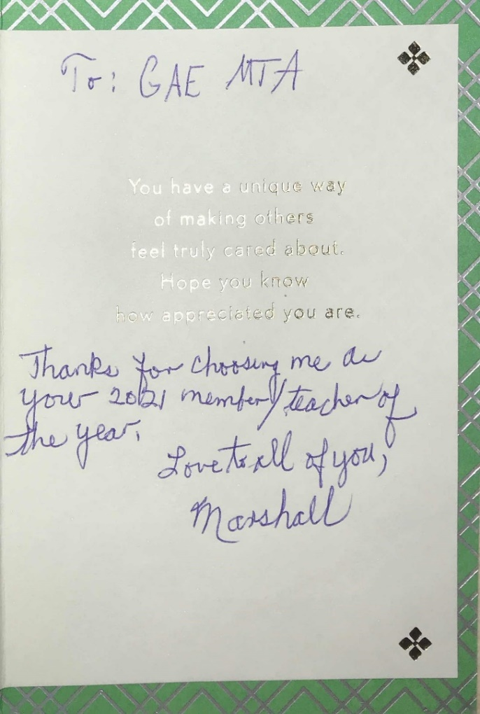

The card reads: Thank you for being so thoughtful. You have a unique way of making others feel truly cared about. Hope you know how appreciated you are.

And, in Marshall’s own handwriting (and his beautiful penmanship), he writes,

Thanks for choosing me as your 2021 member/teacher of the year.

Love to all of you,”

**Marshall**

**PLEASE REPLY:**  
Below is the budget proposal. I am asking members to **please reply to this email** to let me know if you accept the budget or not. If you have any questions, please contact Treasurer, **Joan Witte** by email ([jcwitte63@gmail.com](mailto:jcwitte63@gmail.com)) or phone (260) 239-8704

**And, last, but not least:**

**Announcing the GATEWAY ARCH EAST PROGRAMS for 2021-2022**

See below:

GATEWAY ARCH EAST PROGRAMS 2021-2022 (Draft)

|  |  |  |
| --- | --- | --- |
| September 10 | “20/20 Vision: Building a Foundation for Expressive Performance”. Venue: 231 W. Water’s Edge Dr.  Belleville, IL 62221 | Janna Williamson |
| October 15 | Joint PTRT/GAEMTA program in St. Louis & Zoom.  “The Dog Ate My Homework” | Michelle Sisler |
| November 5/6  November 19 | ISMTA Virtual Conference  Round Table Discussion/ISMTA Conference Feedback |  |
| December | No meeting |  |
| January 21 | Coffee Concert Duet Recital  231 W Waters Edge Dr, Shiloh, IL 62221 | Dr. Stephanie Owen  Gill Cerbin |
| February 12/13  February 18 | AIM Theory Examinations  “How the Music of Bach Helped Shape the Music of Beethoven” | Dr. Mark Ruff |
| March 18  March 26-30 | “Saint Louis as a Cradle of Ragtime”  MTNA Conference Minneapolis | Charlie Kuhn |
| April 2/3/9/10 | AIM Performance Examinations |  |
| May 13 | End of Year Luncheon |  |